Smart delivery project
Main points:
Module A — Authentication & Users
Module B — Delivery Management
Module C — Driver Management
Module D — Dashboard & Frontend
Module E — AI Agent

Module A — Authentication & Users
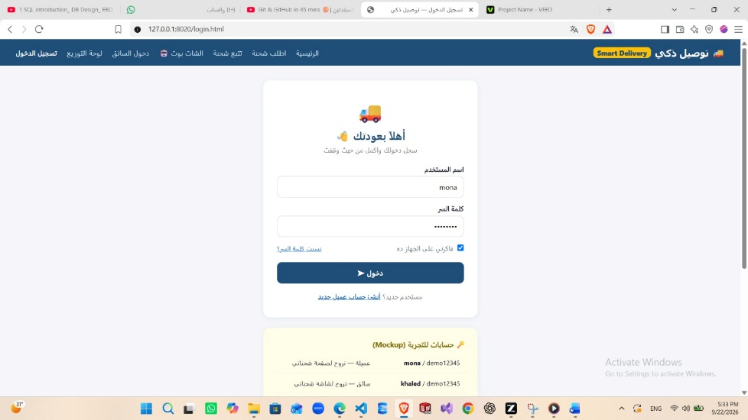
Responsible for:
- Registration
- Login
- Logout
- Profiles
- Roles
- Permissions
Possible roles:
Admin
Manager
Driver
Customer
The specification requires authentication and RBAC, with the AI inheriting the logged-in user's permissions.

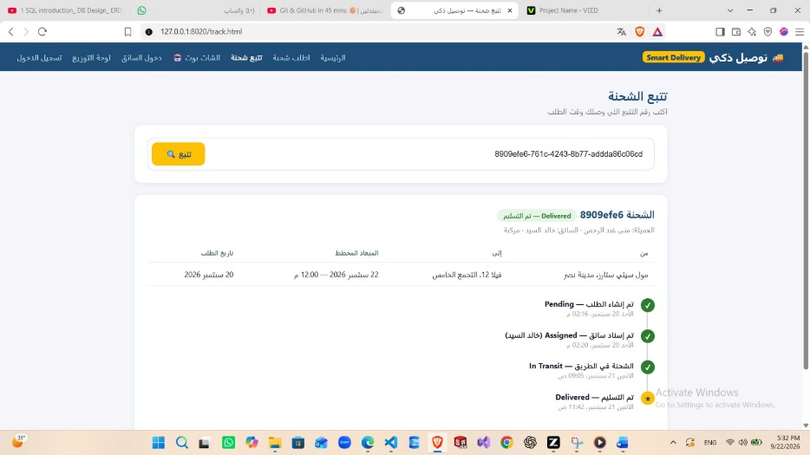
Module B — Delivery Management
This is the core business module.
It manages:
- Customers
- Shipments
- Delivery addresses
- Shipment status
- Delivery assignments
- Dates
- Priority
- Tracking

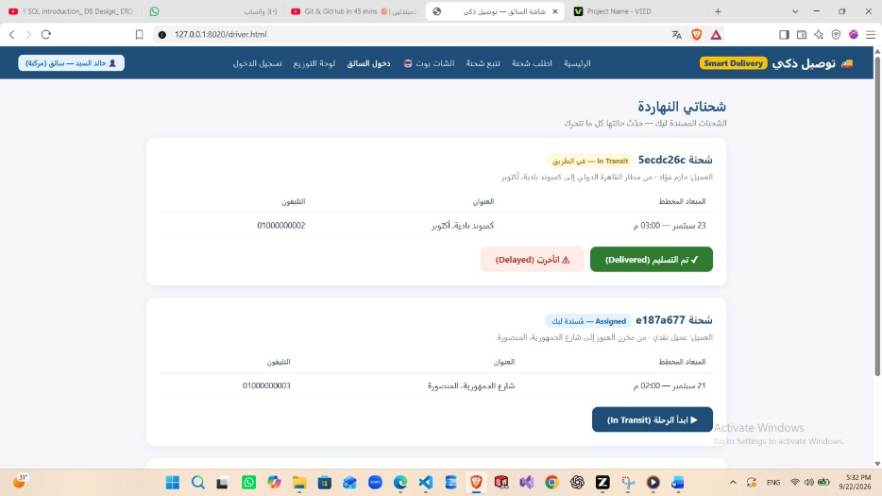
Module C — Driver Management

Responsible for:
- Driver profiles
- Driver availability
- Assigned deliveries
- Delivery history
- Updating shipment status
For example:
Driver: Mohamed

Status: Available

Assigned:
#105 → In Transit
#108 → Pending
#111 → Picked Up

Module D — Dashboard & Frontend
This is where users interact with the system.
Different users should see different dashboards.
Manager:
Total Shipments: 250
Pending: 35
In Transit: 80
Delivered: 120
Delayed: 15
Driver:
My Deliveries

#105 Menouf In Transit
#108 Cairo Pending
#111 Shebin Delivered
Customer:
My Shipments

#105
Status: In Transit
Driver: Mohamed
Expected: Tomorrow

Module E — AI Agent
This is the most important special requirement.
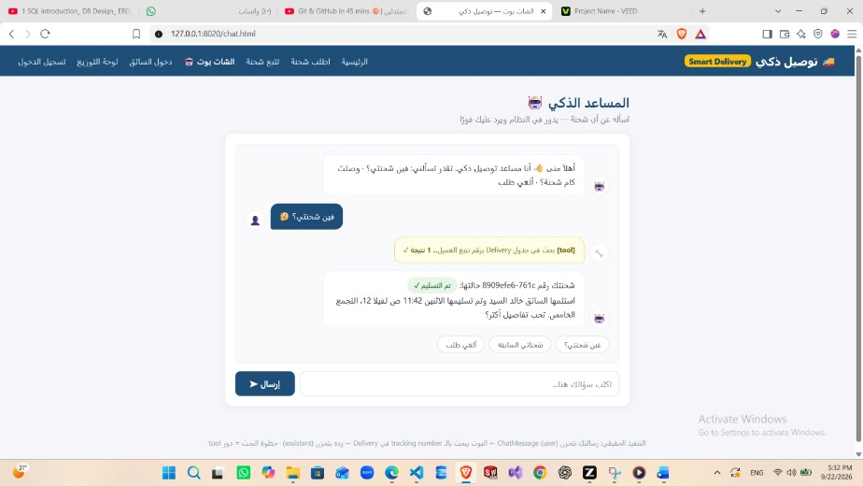
The AI should have tools.
For example:
get_delivery_status()
get_pending_deliveries()
get_delayed_deliveries()
get_available_drivers()
assign_delivery()
update_delivery_status()
The AI could receive:
"Show me all delayed deliveries."
and choose:
get_delayed_deliveries()
Or:
"Reassign shipment 105 to an available driver."
The flow becomes:
User
↓
AI
↓
assign_delivery(...)
↓
Django validates user permission
↓
Django validates shipment + driver
↓
Database updated
↓
Result → AI
↓
User
The specification specifically says AI tools need identity binding, permission checks, parameter validation, and confirmation for destructive actions.

The specification requires the system to manage deliveries, customers, drivers, delivery assignments, and shipment statuses, with the AI Agent able to analyze delayed/pending deliveries and perform actions such as reassignment or status updates through permission-checked Django tools.

